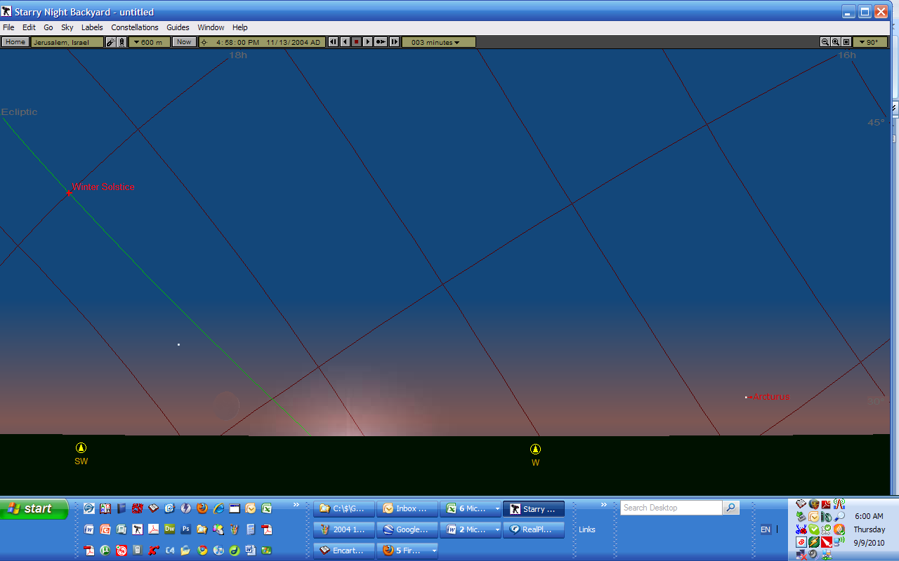
This is Starry Night Backyard’s, my astro-software’s, simulation of the New Moon crescent as it was first being observed from Beitar near Jerusalem on November 13, 2004 at 4:58 PM. Besides the altitude of the moon above the horizon, notice also the planet Mercury and the star Arcturus…

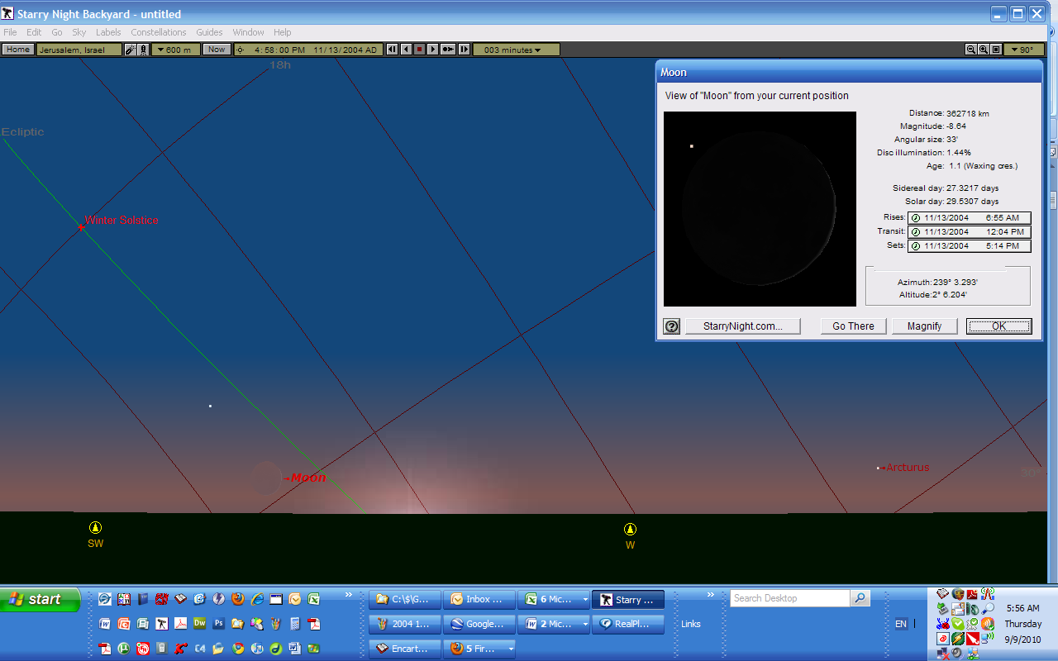
Here are some details pertaining to the moon at that time of first observation.

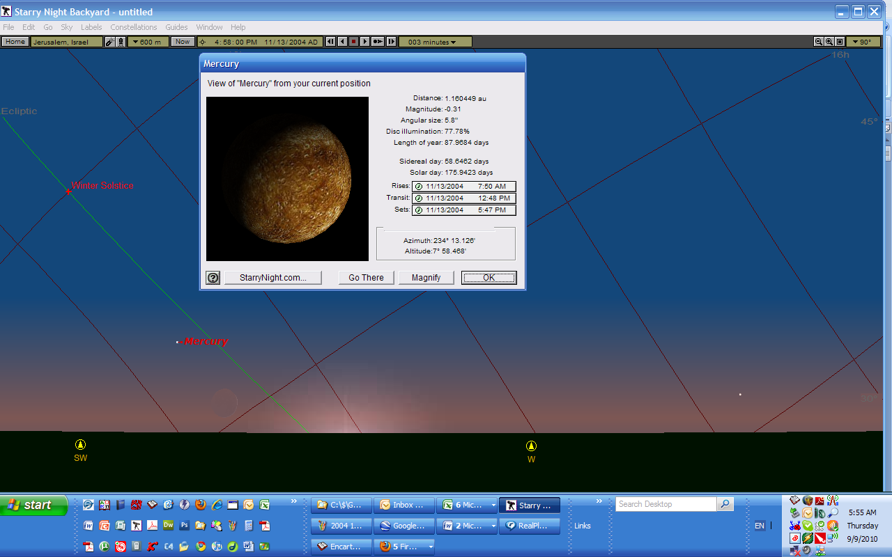
Ditto for the planet Mercury…

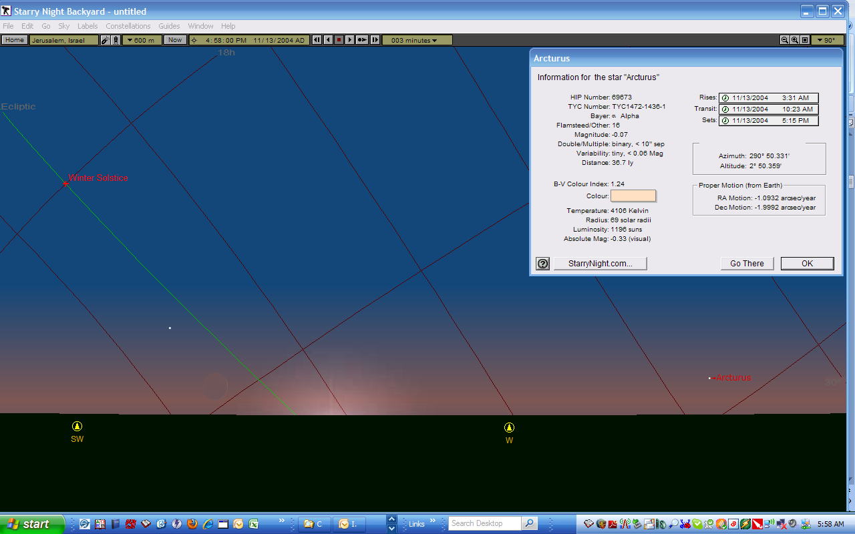
and ditto also for the star Arcturus.

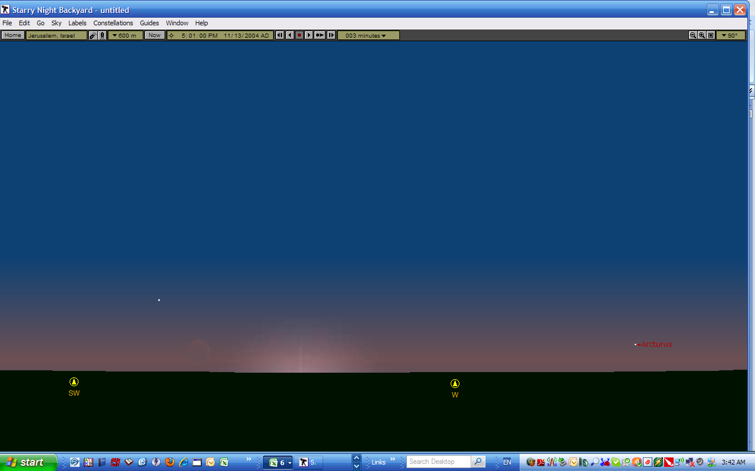
This is the view three minutes later, at the time when the second observer first saw the New Moon crescent on November 13, 2004.

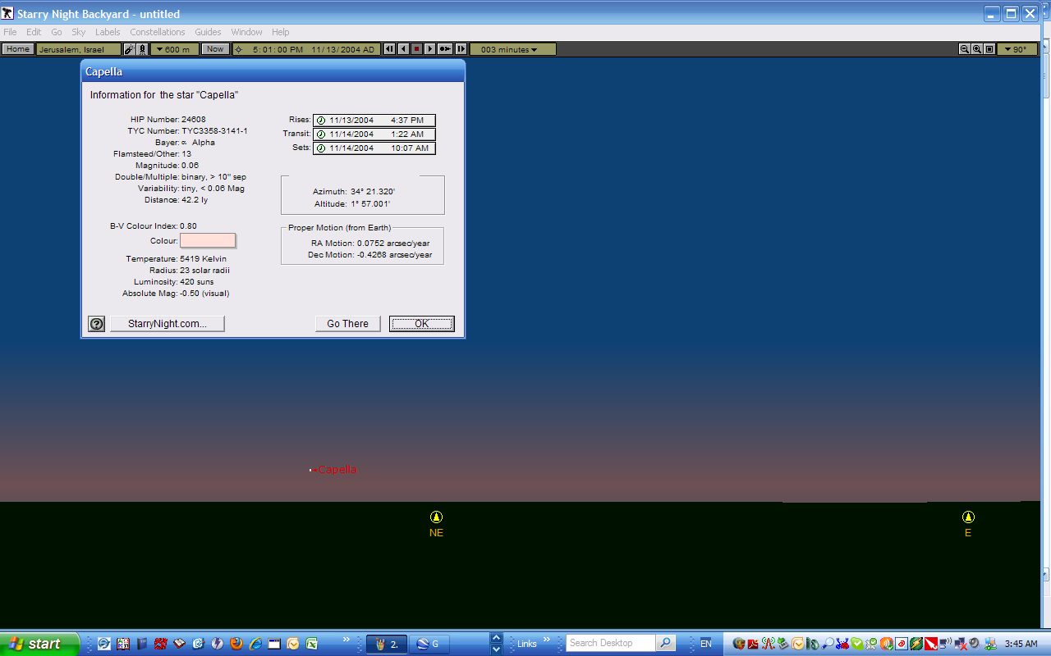
This is the view of the north eastern sky behind that second observer, had he cared to look. One star, Capella, was visible on that north eastern sky.

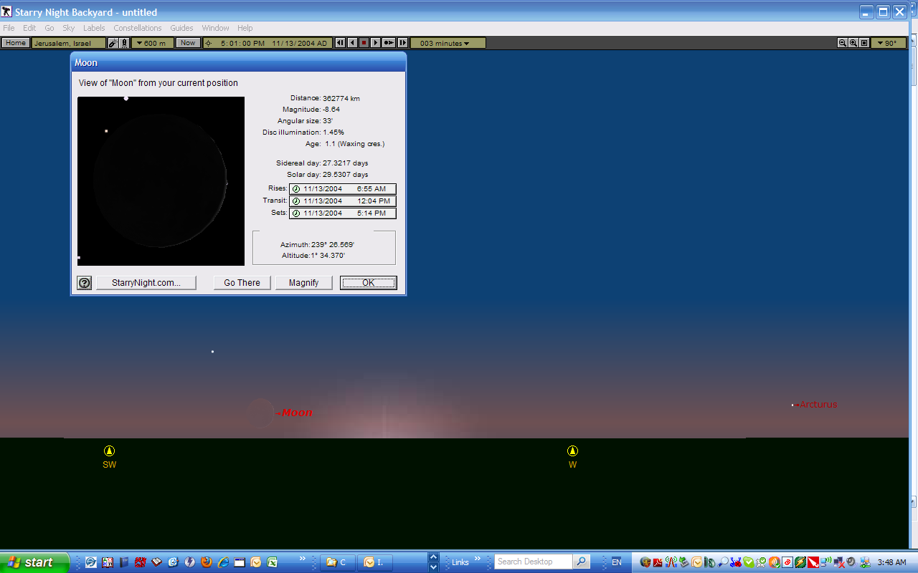
And here are the corresponding details of the moon at that time of the 2nd observer’s first seeing the New Moon crescent.

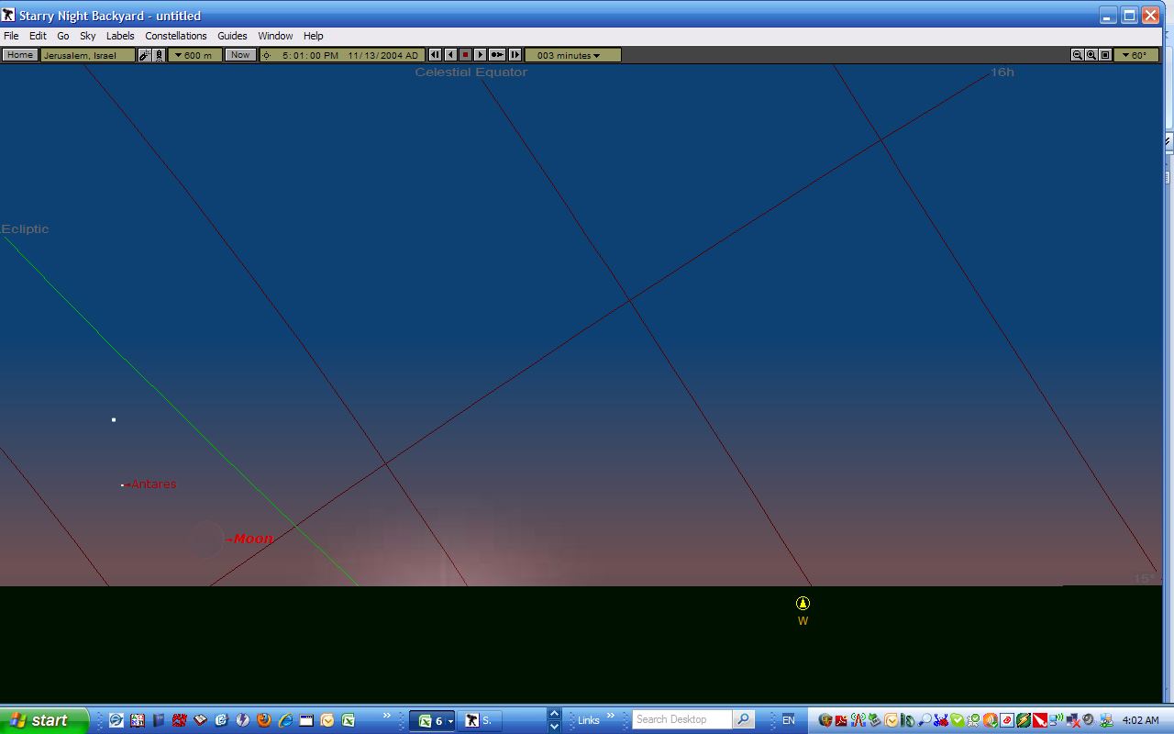
Same thing with the path of the ecliptic (green line) and the celestial grid.

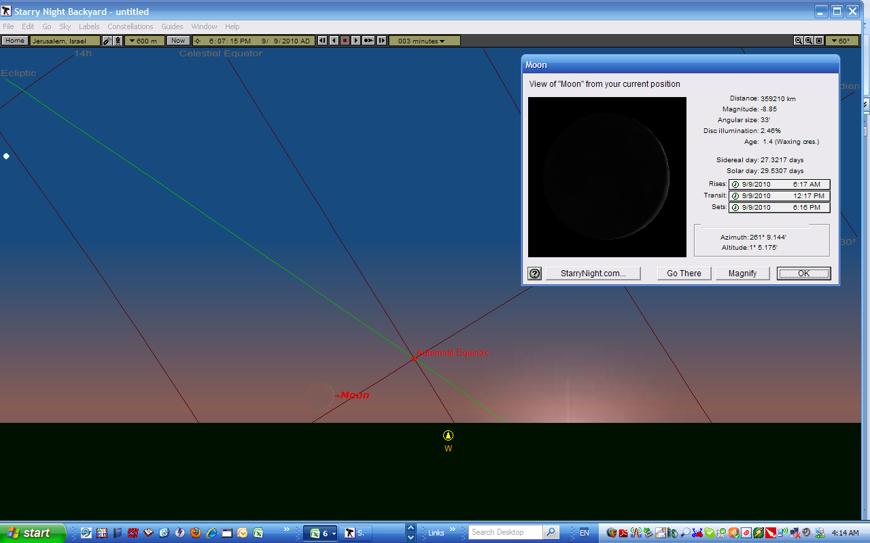
This is the view of the New Moon crescent tonight at a time when the sun is exactly as far below the horizon as it was on November 13, 2004 at 4:58 PM, that is, at the time tonight when the sky will be just as dark as it was when the New Moon was first observed on November 13, 2004. My question is whether the haze at the horizon will obscure tonight’s moon more now than it did then, that is, due to the fact that the moon is a little lower above the horizon tonight than it was on November 13, 2004? But then, the weather conditions are never the same, are they? Perhaps http://yr.no will tell us?

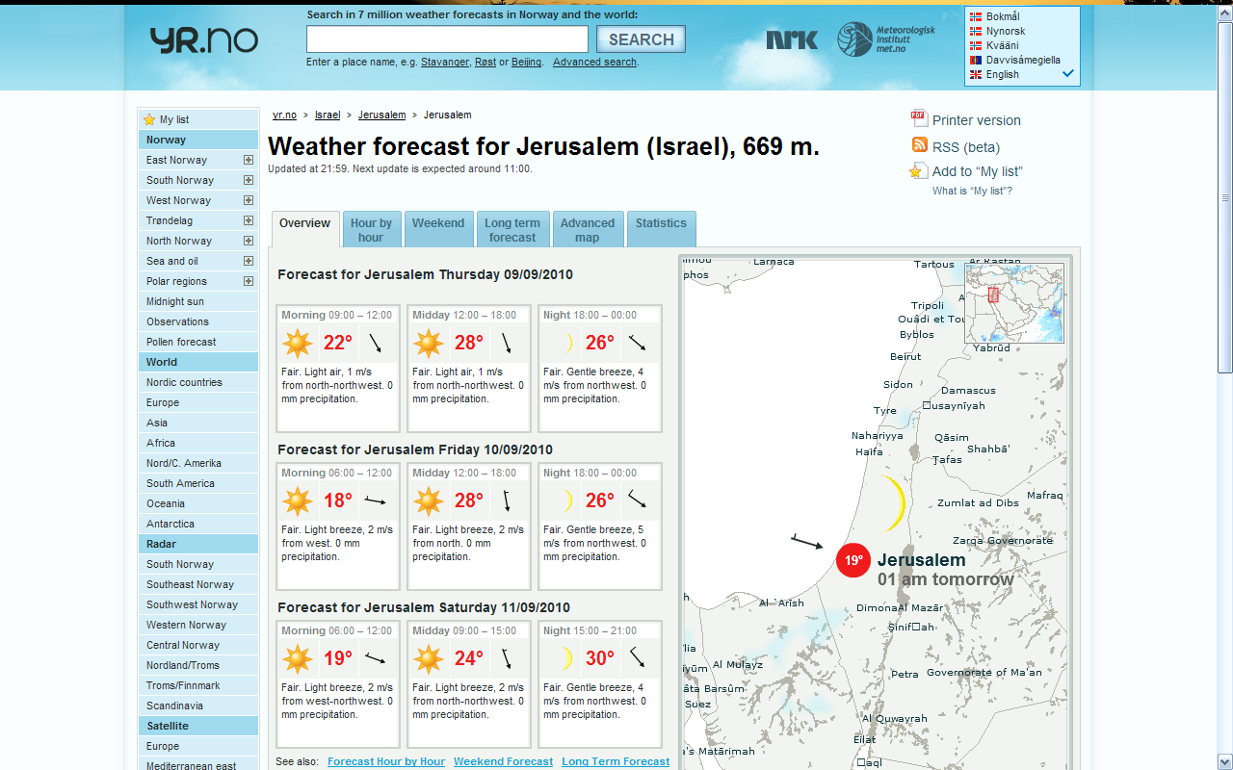
Looks pretty good, doesn’t it?!

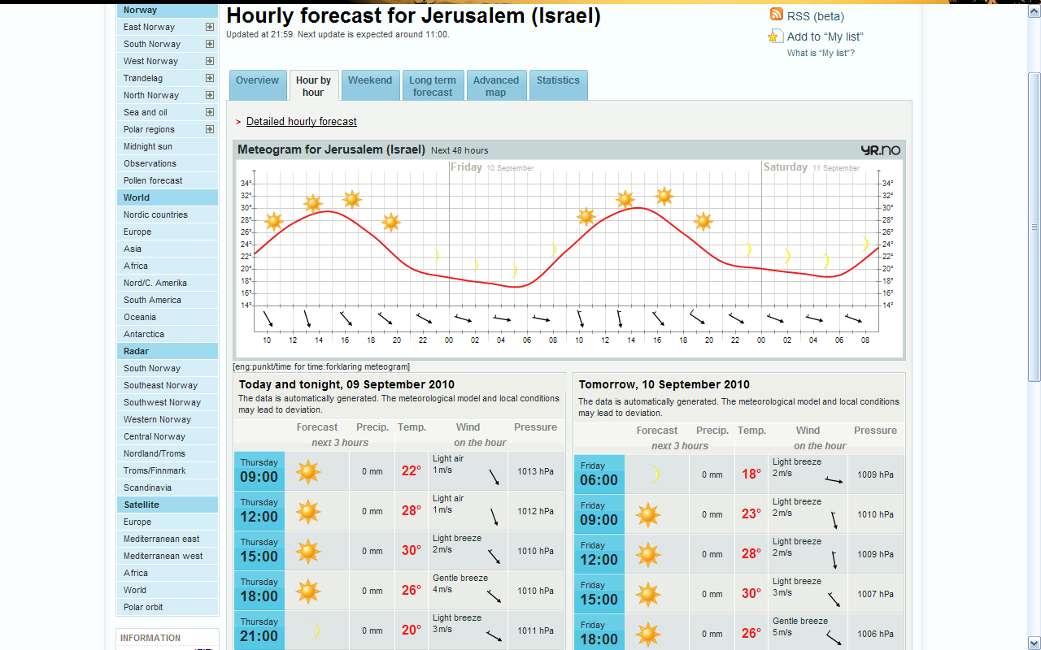
More details re the weather tonight.

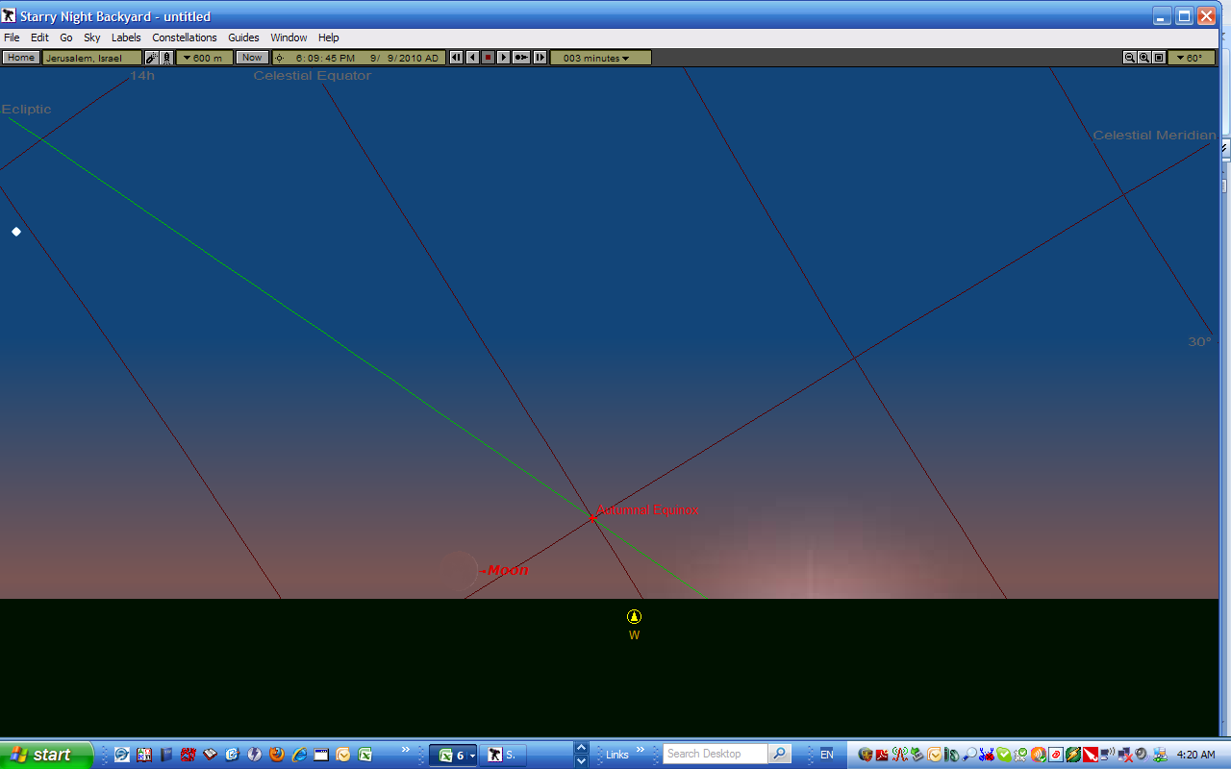
And this is the view of the moon tonight at a time when the sun is exactly as far below the horizon as it was on November 13, 2004 at 5:01 PM, that is, at the time tonight when the sky will be just as dark as it was when the New Moon was first observed by a second eyewitness on November 13, 2004.

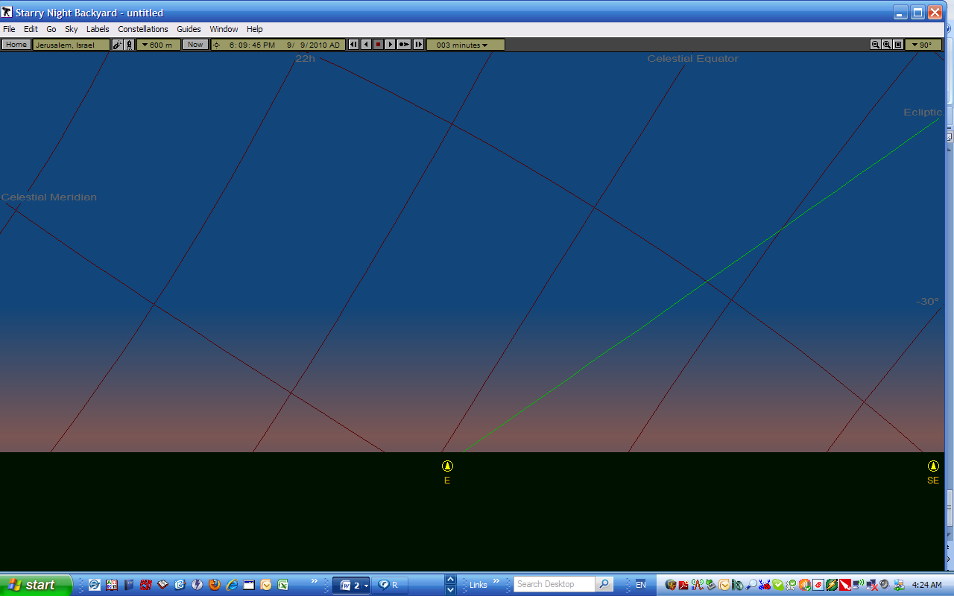
At this same time tonight I am seeing no stars as yet above the eastern horizon, but, remember the degree of darkness is still comparable…

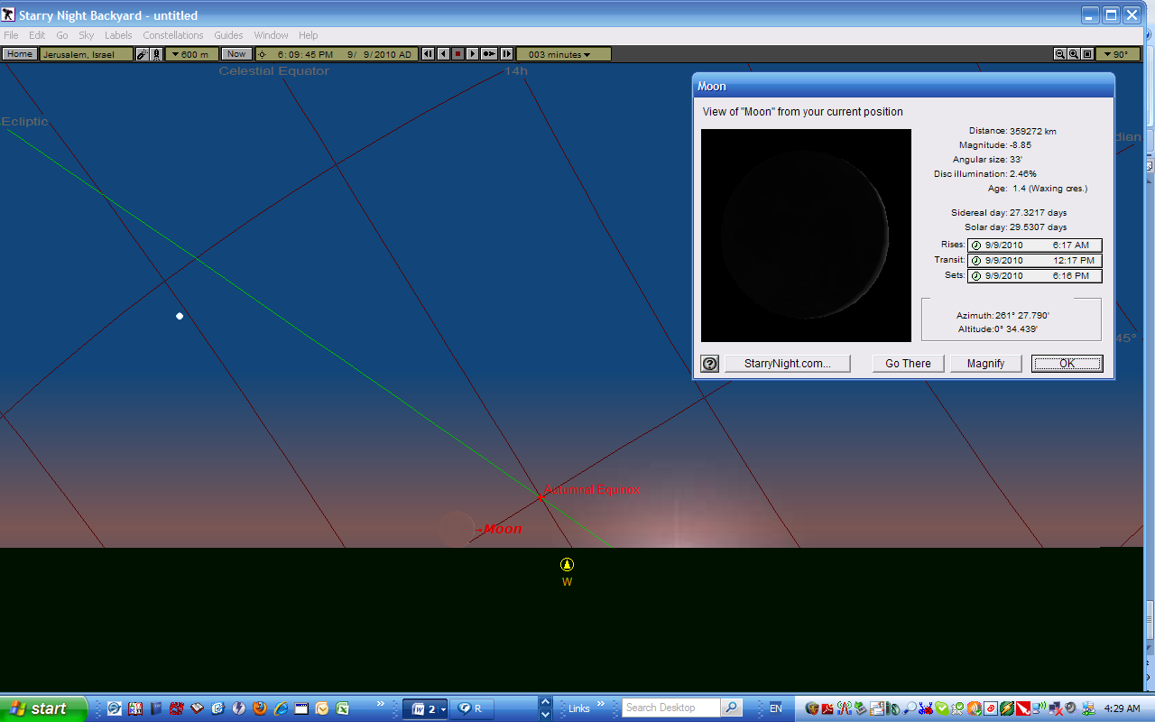
Here are the details pertaining to tonight’s New Moon crescent at this same time, that is, at the time corresponding to that of the second observer’s first seeing the New Moon crescent on November 13, 2004.

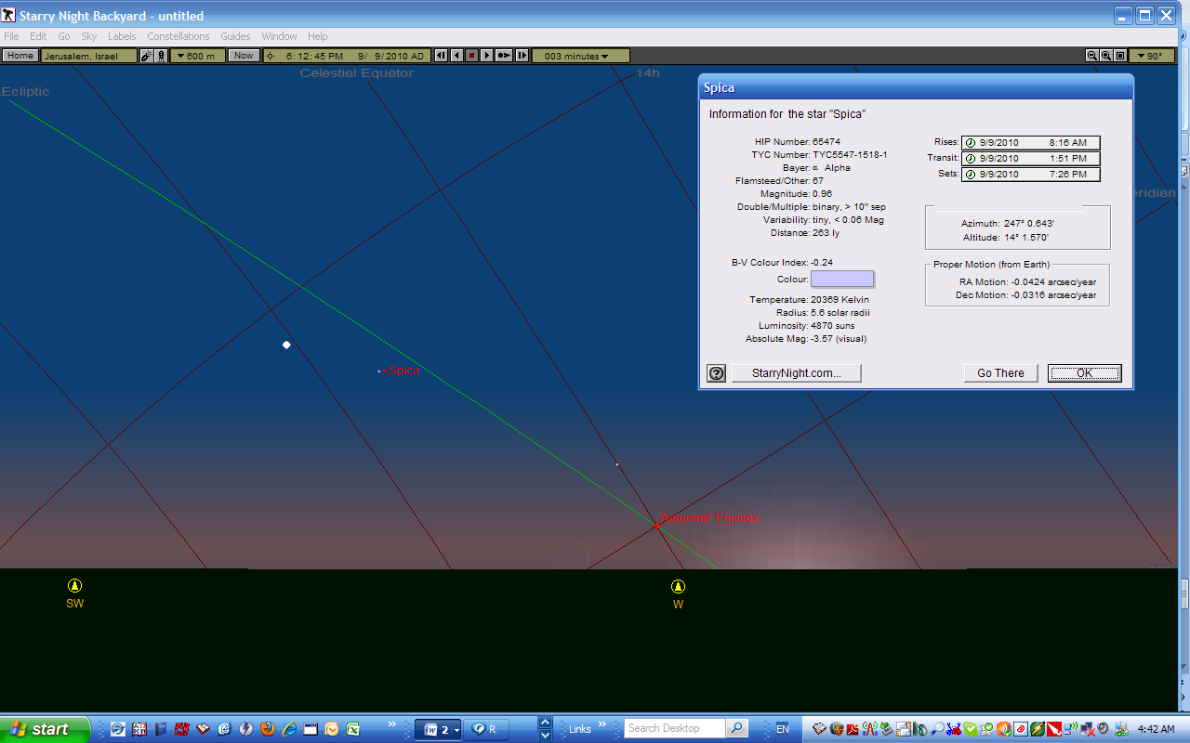
Besides Venus, Spica (magnitude 0.96) and Saturn (magnitude 0.97) will be the first objects seen on the western sky before the setting of moon behind Jerusalem’s horizon (provided only that the sky is clear enough and that there isn’t too much light pollution.)
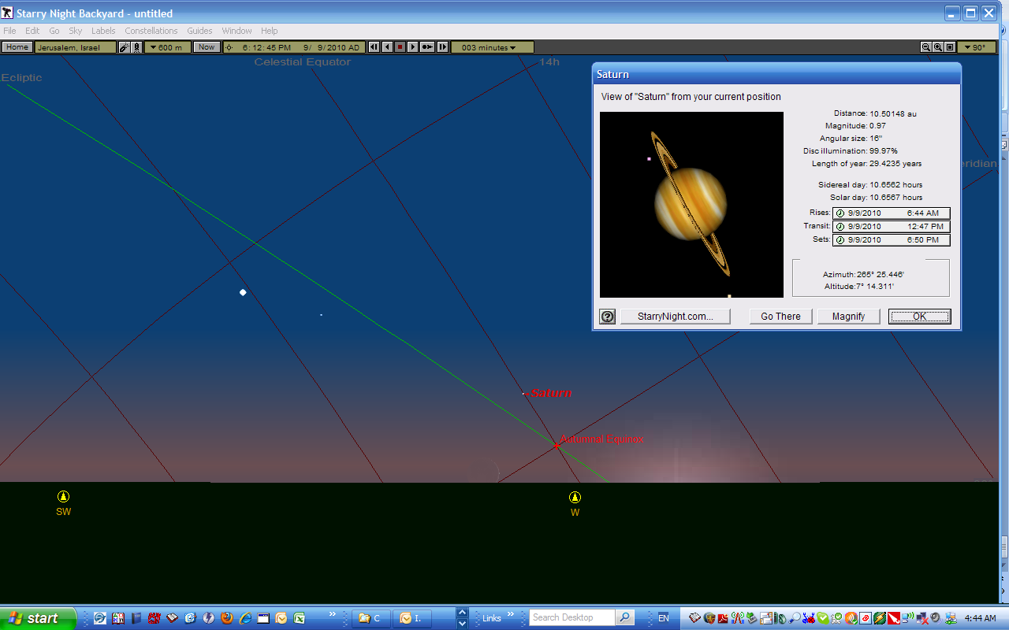
Here are the details for Saturn at the same point in time as above.

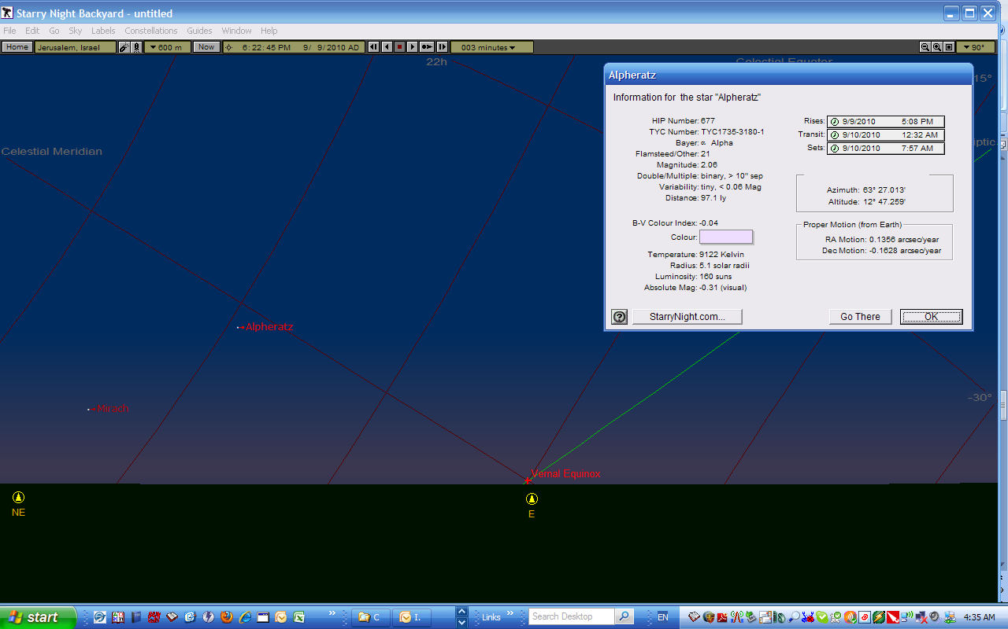
The first two stars (Mirach and Alpheratz) on the eastern sky are not seen on my astro-software until 6:22:45 PM…
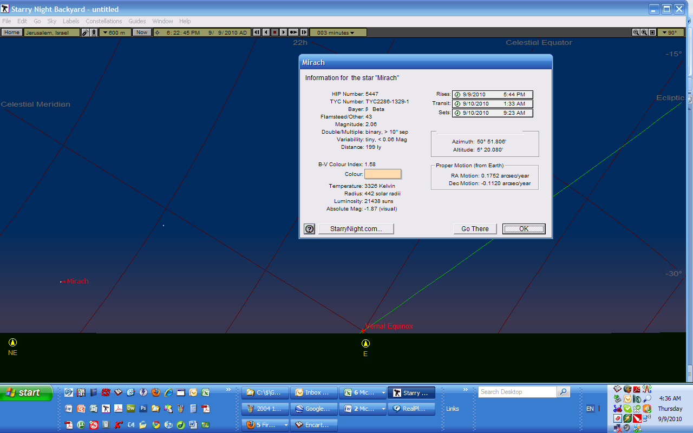
Notice the names of those two stars!!!

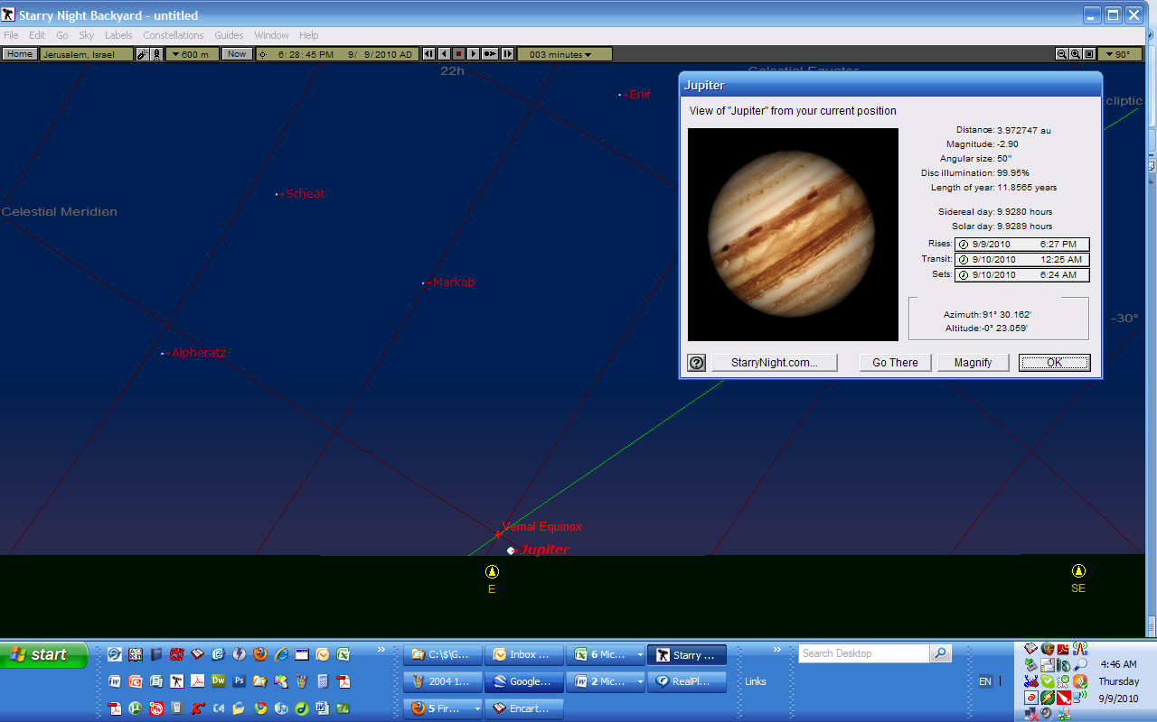
After moonset, at 6:28 PM, Jupiter may be seen rising above the eastern horizon…
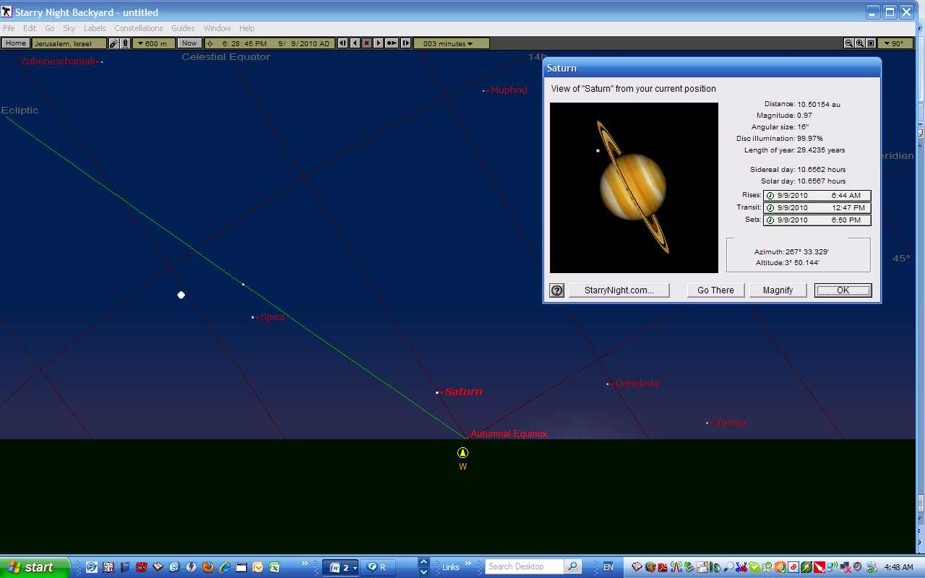
Saturn is still above the horizon in the west while Jupiter is rising above the horizon in the east…

