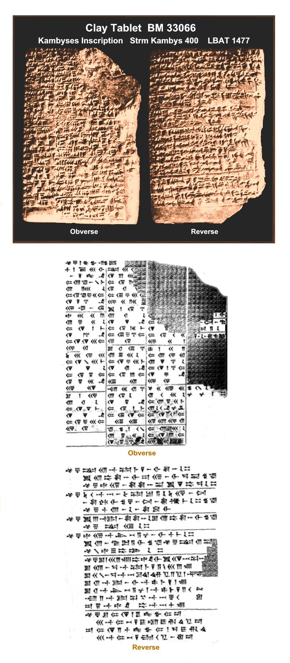

I found the following image and English translation at Biblical Archaeology. The partial German translation by Kugler is available at this link.
All footnotes and links are my own and represents my attempts to verify for myself the validity of the placement in time of these astronomical observations.

Obverse

I

1 Year 7 of Kambyses. (the 1st of which was identical with)
the 30th (of the preceding month, sunset to moonset:) 23º.
2 Month 1º. the 1st the moon became visible:
3 1 bēru sunset to moonset.
4 Night of the 13th: moonrise to sunset: at 9º.
5 The 13th. moonset to sunrise: 2º 20’.
6 Night of the 14th: sunset to moonrise: 8º 20’.
7 The 14th, sunrise to moonset: 7º 40’.
8 The 27th: (moonrise to sunrise:) at 16º.
9 Month II, (the 1st of which was identical with) the :30th
(of the Preceding month: sunset to moonset:) 23º.
10 The 13th. moonset to sunrise: 8º 20’.
11 Night of the 14th. moonrise to sunset: 1º.
12 The 14th. sunrise to moonset: 1º 40’.
13 Night of the 15th, sunset to moonrise: 14º 30’.
14 The 27th, (moonrise to sunrise:) 21º.
15 Month 3º, (the 1st of which was identical with) the 30th
(of the preceding month, sunset to moonset:) 18º 30’.
16 Night of the 14th. moonrise to sunset: 9º 30’.
17 The 14th, moonset to sunrise: 4º.
18 Night of the 15th, sunset to moonrise: 5º.
19 The 15th, sunrise to moonset: 8º 30’.
20 The 27th, (moonrise to sunrise:) 15º.
21 Month 4º, the 1st (of which followed the 30th of the
preceding month, sunset to moonset:) 27º.
22 The 13th, moonset to sunrise: 11º.
23 Night of the 14th. moonrise to sunset: 4º.
24 The 14th. sunrise to moonset: 4º.
25 Night of the 15th. sunset to moonrise: 8º 30’.
26 The 27th, (moonrise to sunrise:) 15º.

II

1 Month 5º, (the 1st of which was identical with} the 30th
(of the preceding month, sunset to moonset:) 10+[x]º.
2 The 14th, [moonset to sunrise:] 3º 30’.
3 Night of the 13th, [moonrise to sunset:] 2º 20+[x]’.
4 The 15th, sunrise to moonset: 1 Io.
5 Night of the 16th. sunset [to moonrise:) 7º 30’.
6 The 27th, (moonrise to sunrise:) 22º 30’.
7 Month 6º, the 1st {of which followed the 30th of the
preceding month, sunset to moonset:) 15º 40’.
8 The 13th, moonset to sunrise: 11º.
9 The 14th, sunrise to moonset: 4º.
10 Night of the 15th. moonrise to sunset: 1º 20’.
11 Night of the 16th. sunset to moonrise: 8º 40’.
12 The 28th, (moonrise to sunrise:) 15º.
13 Month 7º, the 1st (of which followed the 30th of the
preceding month, sunset to moonset:) 16º 40’.
14 The 13th, moonset to sunrise: 6º 30’.
15 Night of the 14th. moonrise to sunset: 7º 30’.
16 The 14th, sunrise to moonset: 12º.
17 Night of the 15th. sunset to moonrise: 3º.
18 The 26th, (moonrise to sunrise:) 22º.
19 Month 8º, (the 1st of which was identical with) the 30th
(of the preceding month. sunset to moonset:) 12º 40’.
20 The 13th, moonset to sunrise: 15º.
21 The 14th, sunrise to moonset: 5º.
22 Night of the 15th. moonrise to sunset: 1º.
23 Night of the 16th. sunset to moonrise: 14º.
24 The 26th, (moonrise to sunrise:) 26º.
(the following paragraph extends over cols. 2º and 3º)
25 Month 12º the 1st (of which followed the 30th of the
preceding month, sunset to moonset:)19º.
Night of the 13th, moonrise to sunset: [x]+1º 30’.
26 The 13th, moonset to sunrise: 5º 20’. Night of the 14th.
sunset to moonrise: 3º.
27 The 14th, sunrise to moonset: 5º 40’. The 27th,
(moonrise to sunrise:) 21º.

III

1 The 1[3th, moonset to sunrise: ....]
2 Night of the l|4th. moonrise to sunset: ....]
3 The 14th, [sunrise to moonset:] 5º.
4 Night of the 15th, [sunset to moonrise:] 10º 20’.
5 The 27th, (moonrise to sunrise:) 24º.
6 Month 11º, the 1st (of which followed the 30th of the
preceding month, sunset to moonset:) 22º.
7 Night of the 13th, moonrise to sunset: 17º 20’.
8 The 13th, moonset to sunrise: 4º 40’.
9 Night of the 14th, sunset to moonrise: 1o 40’.
10 The 14th, sunrise to moonset: 7º.
11 The 27th, (moonrise to sunrise:) 17º.
12 Month 12º, (the 1st of which wras identical with) the 30th
(of the preceding month. sunset to moonset:) 15º 30’.
13 The 12th, moonset to sunrise: 10º 30’.
14 Night of the 13th, moonrise to sunset: 5º 20’.
15 The 13th, there was no "moonset to sunrise"
or "sunrise to moonset".
16 Night of the 14th, sunset to moonrise: 10º.
17 The 25thsle, (moonrise to sunrise:) 23º: the 27th,
(moonrise to sunrise:) 12º.

Right edge

1’ [....]....
2’ [(Mercury’s) ....] first appearance ....
3’ [....] last appearance in the east in the
4’ [rear’] foot of Leo.
5’ [.... first appearance] in the west in ….
(break)
1’’ [....]....[....]
2’’ [....]....[....]
3’’ Month XII, the 19th, last appearance in the west.
4’’ in the Ribbon of the Fishes.

Reverse

1 Year 7, month 5º, the 22nd,
Jupiter’s last appearance in front of Virgo.
2 Month 6º, the 22nd,
first appearance behind Virgo.
Month 10º, the 27th,
it became stationary in front of Libra.
Month 12º was intercalary.
3 Year 8, month 2º, the 25th,
it became stationary in the area of Virgo.
Month 6º, the 4th,
last appearance behind Libra.
4 Year 7, month 3º, the 10th.
Venus last appearance in the west in the beginning of Leo.
Month 3º, the 27th,
5 first appearance in the east in the area of Cancer.
Month 12º, the 7th,
last appearance in the east in the area of Pisces.
Month XII was intercalary.
6 Year 8, month 1º, the 13th,
first appearance in the west in the area of the Chariot.
7 Year 7, month 6º, the 3rd.
Saturn’s last appearance in the area of Virgo.
Month 7º, the 13th,
first appearance behind Virgo.
Month 12º was intercalary.
8 Year 8, month 5º, the 29th, last appearance.
9 Year 7, month 2º, the 28th,
Mars last appearance in front of Gemini.
10 Month 6º, the 13th, first appearance in the foot of Leo.
Month 12º was intercalary.
Year 8, month 5º, the 12th, it became stationary.
11 Year 9, month 2º, the 9th, last appearance behind α Leonis.
12 Year 7, month 7º, the 1st,
the moon became visible 3 cubits behind Mercury.
Month 6º, the 24th, Venus was 1+[x cubits’ | above Mars.
13 Month 7º, the 23rd, last part of the night.
Jupiter was 3 cubits above the moon.
14 Month 7º, the 29th, last part of the night,
Venus on the north side [came near] 2 fingers to Jupiter.
15 Month 7º, the 12th, Saturn was 1 cubit in front of Jupiter.
16 Month 7º, the 11th, Mars came near to Jupiter 2 fingers.
17 Month 8º, the 2nd, Saturn passed 8 fingers above Venus.
18 Month 10º, the 5th, Mercury was ½ cubit behind Venus.
19 Year 7, month 4º, night of the 14th, 1 ⅔ bēru after sunset.
20 the moon made a total eclipse,
a little remained: the north wind blew.
21 Month 10º, night of the 14th,
when 2 ½ bēru remained to sunrise.
22 the moon made a total eclipse: the south and north winds blew in it.

